Proyecto SisCoTe

Documento de Diseño

Versión 1.0

Lima, 2014

Historial de Versiones

|  |  |  |  |
| --- | --- | --- | --- |
| **Date** | **Version** | **Description** | **Author** |
| 30/09/2014 | 1.0 | Se crea la versión inicial del documento | Liliana Ramírez |
| 07/09/2014 | 1.5 | Agregados Diagramas de diseño y Pantallazos | Akira Tabuchi |
| 07/09/2014 | 1.6 | Agregado Diseño Físico del Modelo de Base de datos | André Calderón |
| 20/10/2014 | 1.7 | Modificación del Modelo Físico de Base de datos y agregado el diccionario de datos | André Calderón |

# Introducción:

Este documento es una versión preliminar preparada para ser incluida en el proyecto SISCOTE y provee una visión global del enfoque de desarrollo propuesto.

Para el desarrollo del proyecto se hace uso de la metodología de desarrollo de software Rational Unified Process (RUP). Se incluirá el detalle para las fases de Inicio y Elaboración y adicionalmente se esbozarán las fases posteriores de Construcción y Transición para dar una visión global de todo proceso.

El enfoque desarrollo propuesto constituye una configuración del proceso RUP de acuerdo a las características del proyecto, seleccionando los roles de los participantes, las actividades a realizar y los artefactos (entregables) que serán generados. Este documento es a su vez uno de los artefactos de RUP

## Propósito

El propósito del Documento de Diseño es proporcionar una orientación general sobre la arquitectura del proyecto dirigida al equipo de desarrollo de software.

## Definiciones, siglas y abreviaturas

RUP: Siglas de la metodología de desarrollo de software Rational Unified Process.

SISCOTE: Sistema de Control de Tesis

## 

## Referencias

Documento de Análisis

# Diagrama de Paquetes de Diseño

# E:\Users\Akira\Desktop\Main.png

# Diagrama de Clases

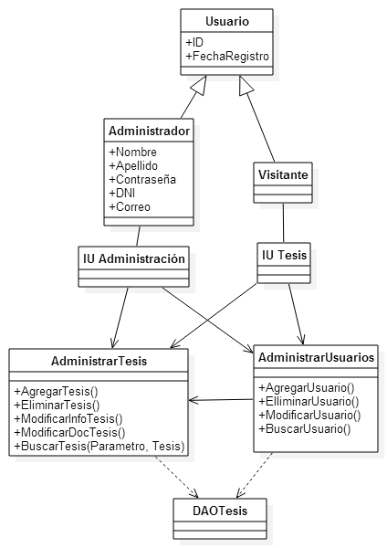

# Modelado de la Base de Datos

## 4.1. Diseño Físico

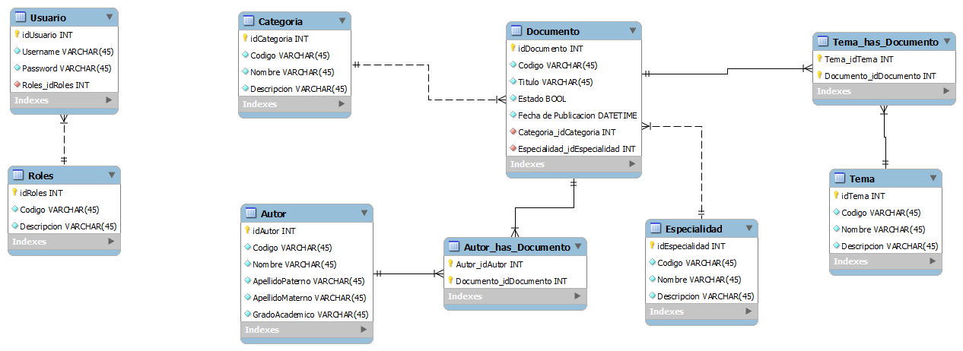

## 4.2. Diccionario de Datos

|  |  |
| --- | --- |
| Indice de Tablas | Leyenda |
| * Autor * Autor_has_Documento * Categoria * Documento * Especialidad * Roles * Tema * Tema_has_Documento * Usuario | * Primary Key (PK) * Not NULL (NN) * Unique (UQ) * Binary (BIN) * Unsigned (UN) * Zero fill empty value (ZF) * Autoincrement (AI) |

|  |  |  |  |  |  |  |  |  |  |
| --- | --- | --- | --- | --- | --- | --- | --- | --- | --- |
| Autor | | | | | | | | | |
|  | | | | | | | | | |
| **Column name** | **DataType** | **PK** | **NN** | **UQ** | **BIN** | **UN** | **ZF** | **AI** | **Default** |
| idAutor | INT | ✔ | ✔ |  |  | ✔ |  | ✔ |  |
| Codigo | VARCHAR(45) |  | ✔ |  |  |  |  |  |  |
| Nombre | VARCHAR(45) |  | ✔ |  |  |  |  |  |  |
| ApellidoPaterno | VARCHAR(45) |  | ✔ |  |  |  |  |  |  |
| ApellidoMaterno | VARCHAR(45) |  | ✔ |  |  |  |  |  |  |
| GradoAcademico | VARCHAR(45) |  | ✔ |  |  |  |  |  |  |

|  |  |  |  |  |  |  |  |  |  |
| --- | --- | --- | --- | --- | --- | --- | --- | --- | --- |
| Autor_has_Documento | | | | | | | | | |
|  | | | | | | | | | |
| **Column name** | **DataType** | **PK** | **NN** | **UQ** | **BIN** | **UN** | **ZF** | **AI** | **Default** |
| Autor_idAutor | INT | ✔ | ✔ |  |  | ✔ |  |  |  |
| Documento_idDocumento | INT | ✔ | ✔ |  |  | ✔ |  |  |  |

|  |  |  |  |  |  |  |  |  |  |
| --- | --- | --- | --- | --- | --- | --- | --- | --- | --- |
| Categoria | | | | | | | | | |
|  | | | | | | | | | |
| **Column name** | **DataType** | **PK** | **NN** | **UQ** | **BIN** | **UN** | **ZF** | **AI** | **Default** |
| idCategoria | INT | ✔ | ✔ |  |  | ✔ |  | ✔ |  |
| Codigo | VARCHAR(45) |  | ✔ |  |  |  |  |  |  |
| Nombre | VARCHAR(45) |  | ✔ |  |  |  |  |  |  |
| Descripcion | VARCHAR(45) |  | ✔ |  |  |  |  |  |  |

|  |  |  |  |  |  |  |  |  |  |
| --- | --- | --- | --- | --- | --- | --- | --- | --- | --- |
| Documento | | | | | | | | | |
|  | | | | | | | | | |
| **Column name** | **DataType** | **PK** | **NN** | **UQ** | **BIN** | **UN** | **ZF** | **AI** | **Default** |
| idDocumento | INT | ✔ | ✔ |  |  | ✔ |  | ✔ |  |
| Codigo | VARCHAR(45) |  | ✔ |  |  |  |  |  |  |
| Titulo | VARCHAR(45) |  | ✔ |  |  |  |  |  |  |
| Estado | TINYINT(1) |  | ✔ |  |  |  |  |  |  |
| Fecha de Publicacion | DATETIME |  | ✔ |  |  |  |  |  |  |
| Categoria_idCategoria | INT |  | ✔ |  |  | ✔ |  |  |  |
| Especialidad_idEspecialidad | INT |  | ✔ |  |  | ✔ |  |  |  |

|  |  |  |  |  |  |  |  |  |  |
| --- | --- | --- | --- | --- | --- | --- | --- | --- | --- |
| Especialidad | | | | | | | | | |
|  | | | | | | | | | |
| **Column name** | **DataType** | **PK** | **NN** | **UQ** | **BIN** | **UN** | **ZF** | **AI** | **Default** |
| idEspecialidad | INT | ✔ | ✔ |  |  | ✔ |  | ✔ |  |
| Codigo | VARCHAR(45) |  | ✔ |  |  |  |  |  |  |
| Nombre | VARCHAR(45) |  | ✔ |  |  |  |  |  |  |
| Descripcion | VARCHAR(45) |  | ✔ |  |  |  |  |  |  |

|  |  |  |  |  |  |  |  |  |  |
| --- | --- | --- | --- | --- | --- | --- | --- | --- | --- |
| Roles | | | | | | | | | |
|  | | | | | | | | | |
| **Column name** | **DataType** | **PK** | **NN** | **UQ** | **BIN** | **UN** | **ZF** | **AI** | **Default** |
| idRoles | INT | ✔ | ✔ |  |  | ✔ |  | ✔ |  |
| Codigo | VARCHAR(45) |  | ✔ |  |  |  |  |  |  |
| Descripcion | VARCHAR(45) |  | ✔ |  |  |  |  |  |  |

|  |  |  |  |  |  |  |  |  |  |
| --- | --- | --- | --- | --- | --- | --- | --- | --- | --- |
| Tema | | | | | | | | | |
|  | | | | | | | | | |
| **Column name** | **DataType** | **PK** | **NN** | **UQ** | **BIN** | **UN** | **ZF** | **AI** | **Default** |
| idTema | INT | ✔ | ✔ |  |  | ✔ |  |  |  |
| Codigo | VARCHAR(45) |  | ✔ |  |  |  |  |  |  |
| Nombre | VARCHAR(45) |  | ✔ |  |  |  |  |  |  |
| Descripcion | VARCHAR(45) |  | ✔ |  |  |  |  |  |  |

|  |  |  |  |  |  |  |  |  |  |
| --- | --- | --- | --- | --- | --- | --- | --- | --- | --- |
| Tema_has_Documento | | | | | | | | | |
|  | | | | | | | | | |
| **Column name** | **DataType** | **PK** | **NN** | **UQ** | **BIN** | **UN** | **ZF** | **AI** | **Default** |
| Tema_idTema | INT | ✔ | ✔ |  |  | ✔ |  |  |  |
| Documento_idDocumento | INT | ✔ | ✔ |  |  | ✔ |  |  |  |

|  |  |  |  |  |  |  |  |  |  |
| --- | --- | --- | --- | --- | --- | --- | --- | --- | --- |
| Usuario | | | | | | | | | |
|  | | | | | | | | | |
| **Column name** | **DataType** | **PK** | **NN** | **UQ** | **BIN** | **UN** | **ZF** | **AI** | **Default** |
| idUsuario | INT | ✔ | ✔ |  |  | ✔ |  | ✔ |  |
| Username | VARCHAR(45) |  | ✔ |  |  |  |  |  |  |
| Password | VARCHAR(45) |  | ✔ |  |  |  |  |  |  |
| Roles_idRoles | INT |  | ✔ |  |  |  |  |  |  |

# Diseño de Pantallas

**5.1. CU Registrar Usuario**

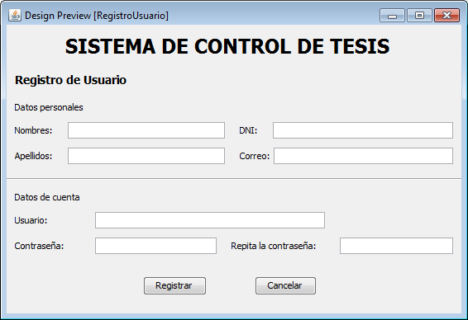

**5.2. CU Ingresar al sistema**

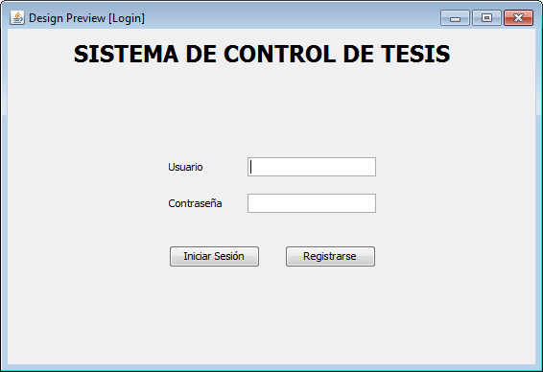

**5.3. CU Administrar documentos de tesis**

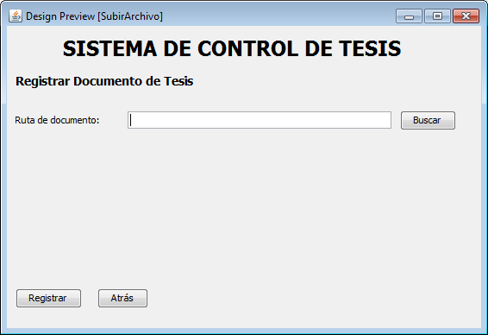

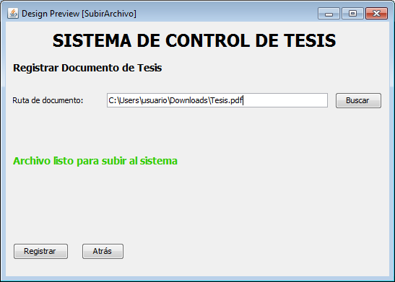

**5.4. CU Administrar información de los documentos de tesis**

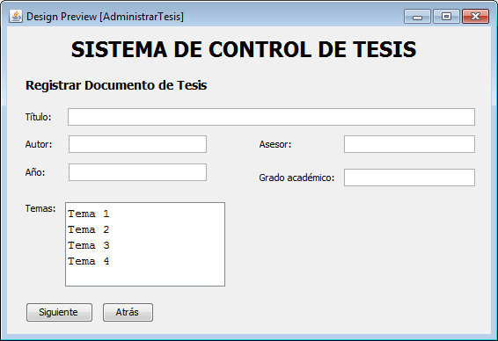

**5.5. CU Buscar tesis por categoría**

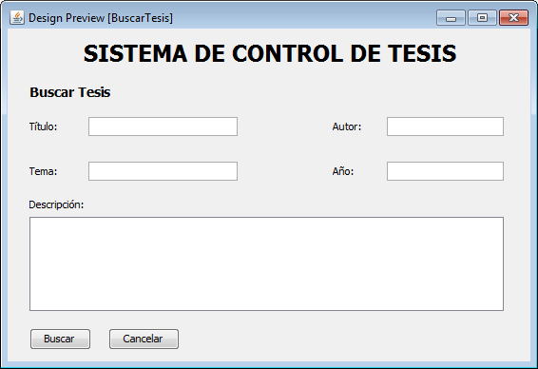

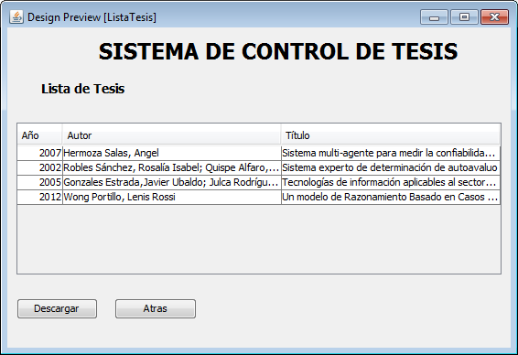

**5.6. CU Administrar cuentas**

